Windows Active Directory Home Lab

Virtualbox Install

To get Windows Server 2019 to run on Virtual box delete the floppy storage than run the program

Active Directory Home Lab Topology

The home lab network topology will be comprised of a Windows 10 client machine connected to an internal network segment with the address range of 172.16.0.100-200. This network segment will be isolated from the public internet by a Network Address Translation (NAT) firewall.

A Dynamic Host Configuration Protocol (DHCP) server will be deployed on the network to automatically assign IP addresses to devices within the internal network segment. This eliminates the need for manual configuration and ensures each device has a unique address for communication.

The Domain Controller (DC) will serve as the central point for managing user accounts and resources within the network. However, in this specific context, it will also function as the internet gateway and **Remote Access Server (RAS)** for the internal network. This multi-functionality is achieved by utilizing two Network Interface Cards (NICs) installed on the DC.

The first NIC, designated as the external NIC, will establish a direct connection to the internet through the existing home router. This connection will provide the DC with access to the public internet. The second NIC, referred to as the internal NIC, will connect the DC to the internal network segment, allowing communication with devices like the client machine.

By acting as the internet gateway, the DC controls and manages how devices within the internal network access the internet. Additionally, by functioning as a **Remote Access Server (RAS)**, the DC enables authorized users to establish remote connections to resources (e.g., files, applications) within the internal network from external locations through a secure tunnel. This functionality provides a layer of security and control within the home lab environment, allowing authorized access while maintaining network separation.

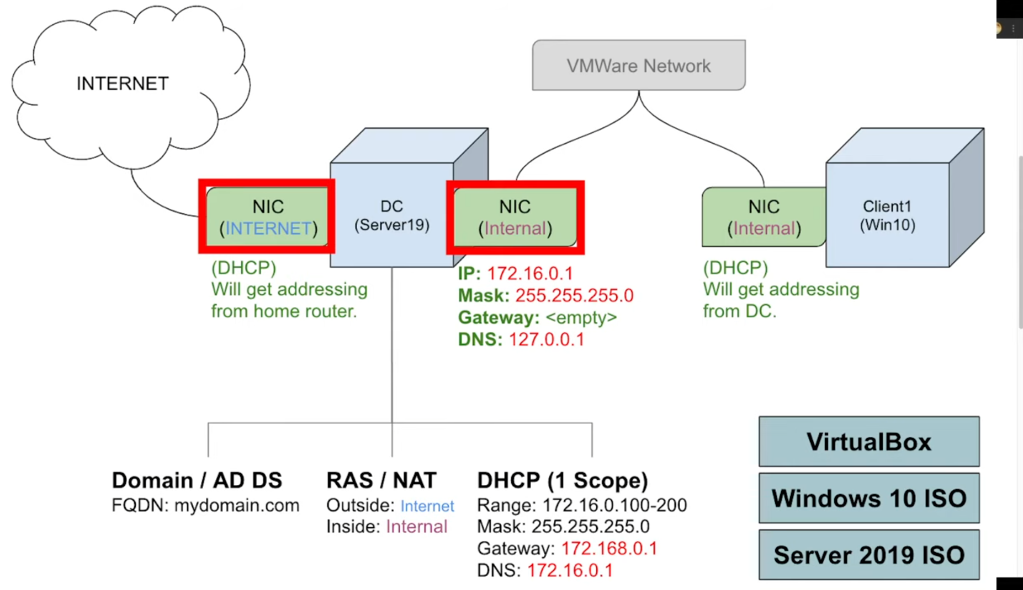

Below is screenshots of the configuration process a key points, not all steps are captured, Consult Windows Active Directory guides is required for inclusive step by step process.

Domain Controller Configuration

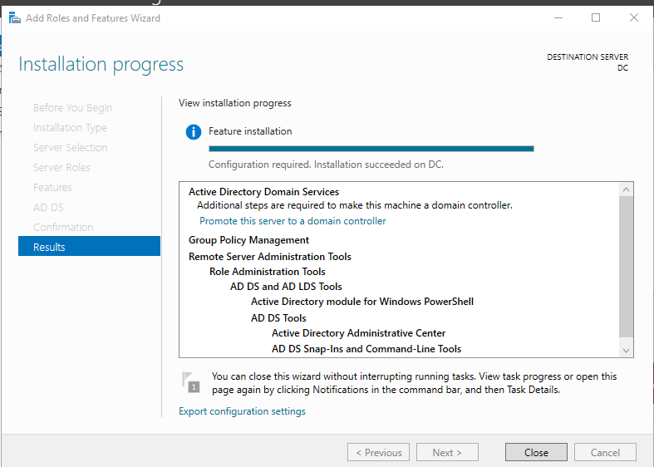

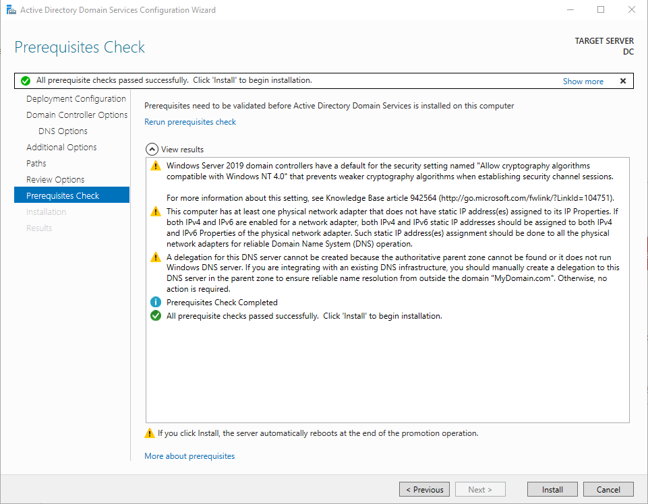

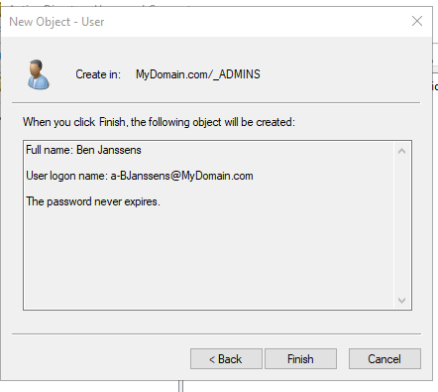

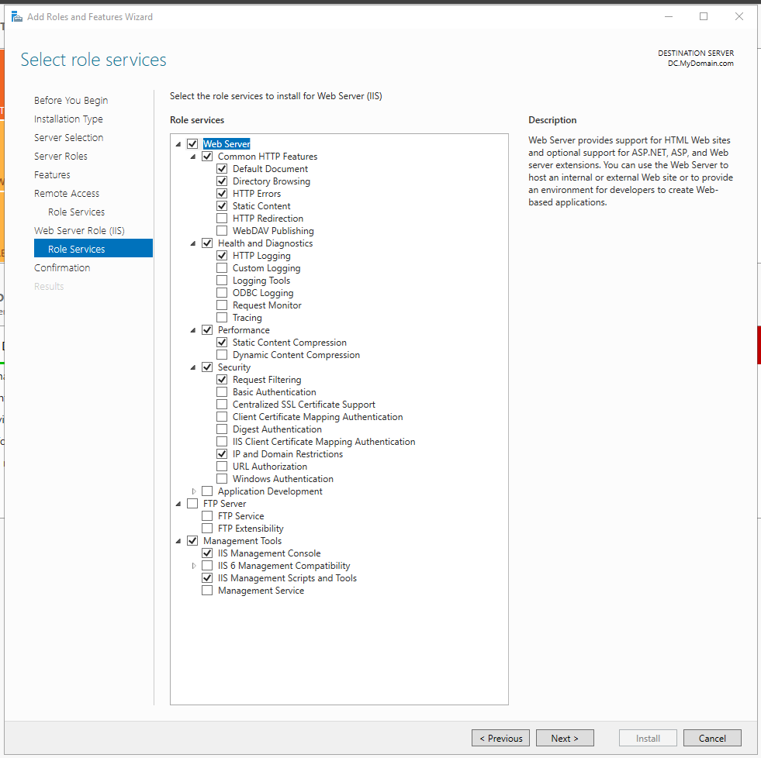

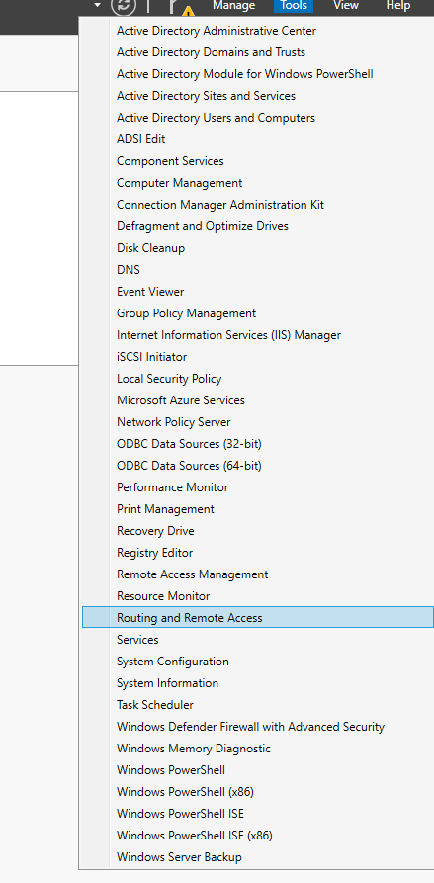

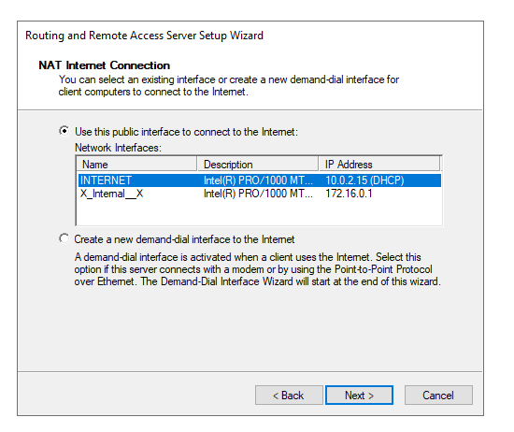

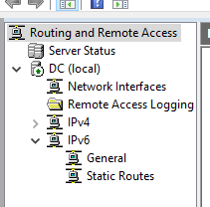

### PowerShell Script Generating Users:

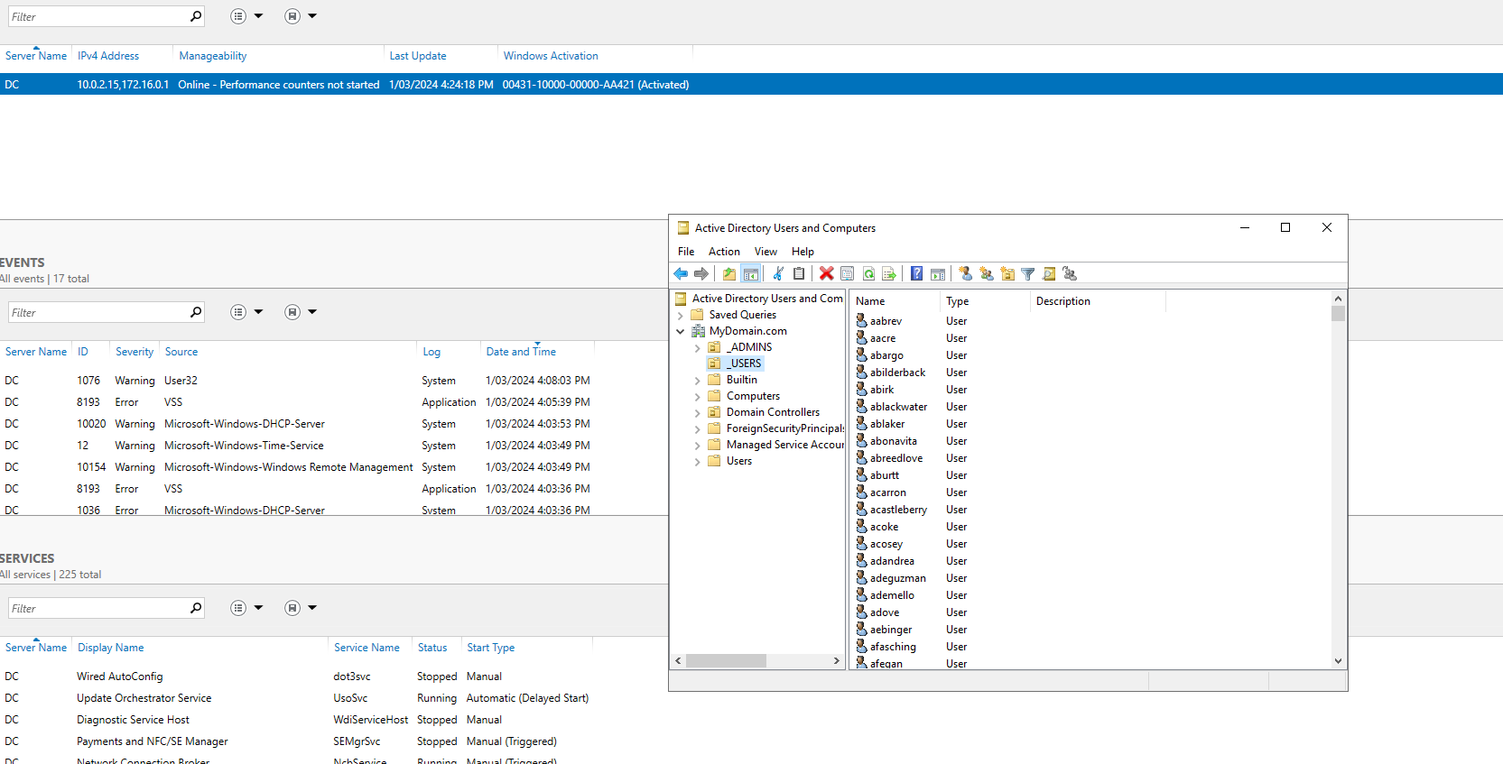

# Configured Client IP Address

